Home/First Page

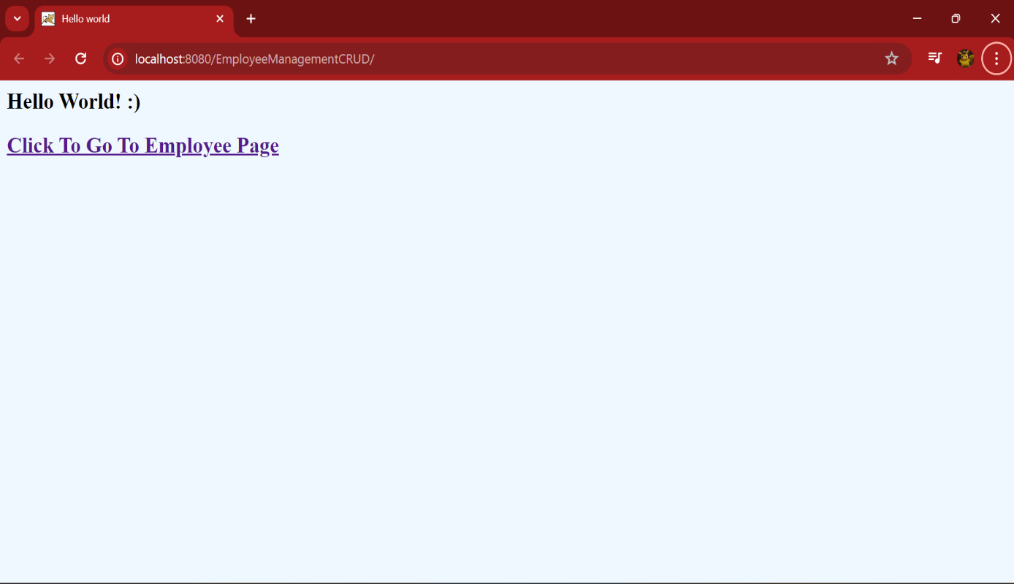

Clicking on "Go To Employees page" link shows up the page as shown below.

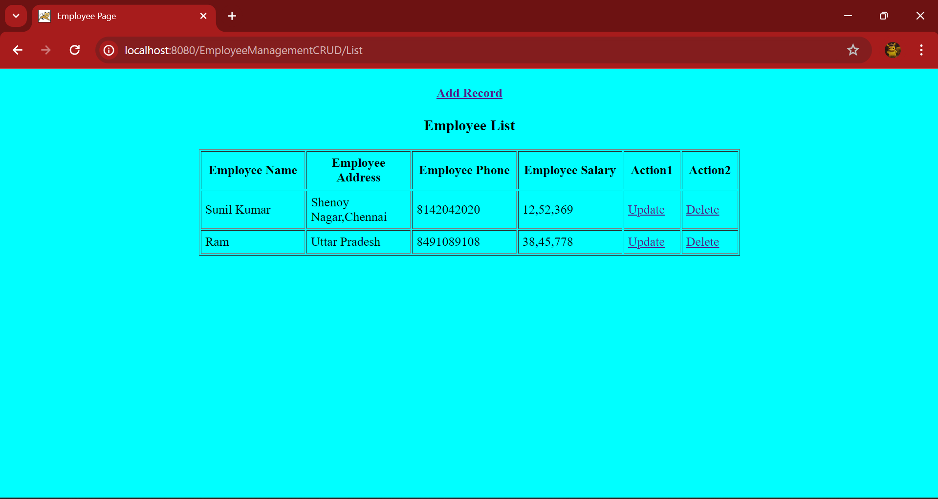

Clicking On “AddRecord” hyperlink – It will Take us to below page

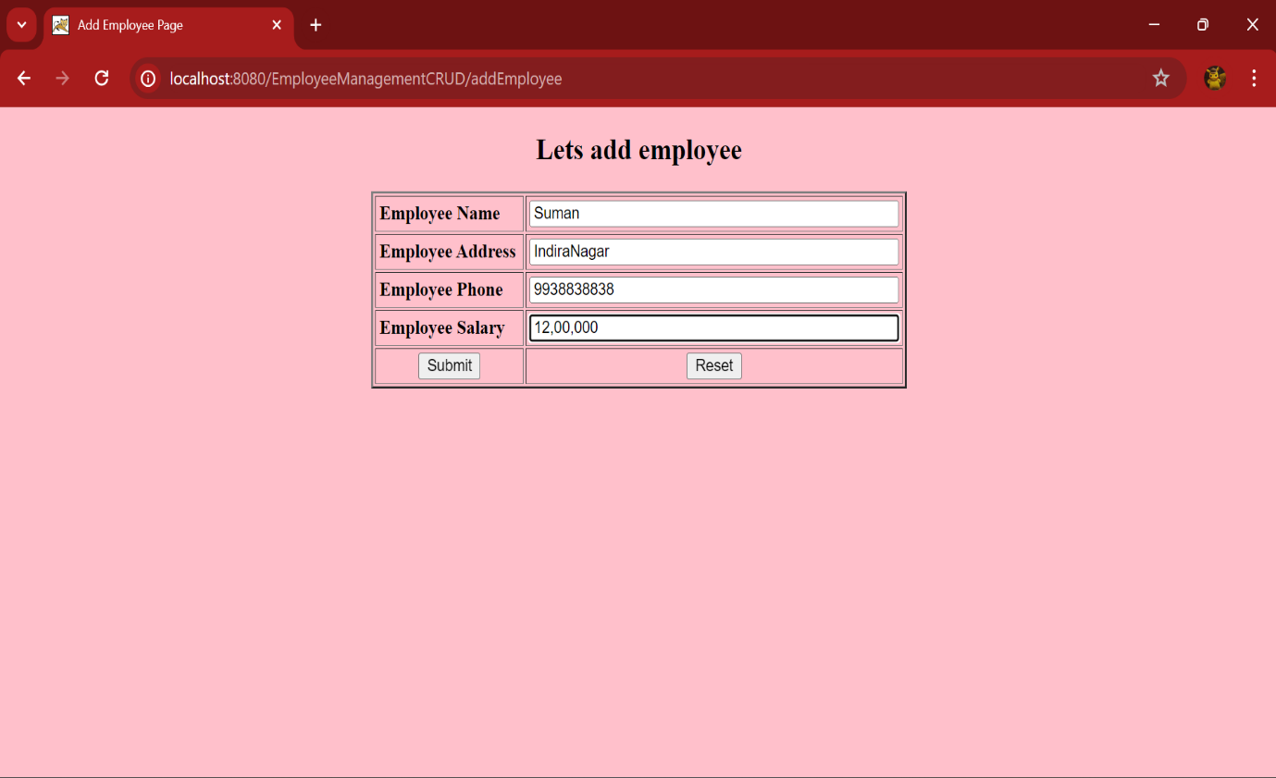

After adding a new record, when “Submit” the updated Page

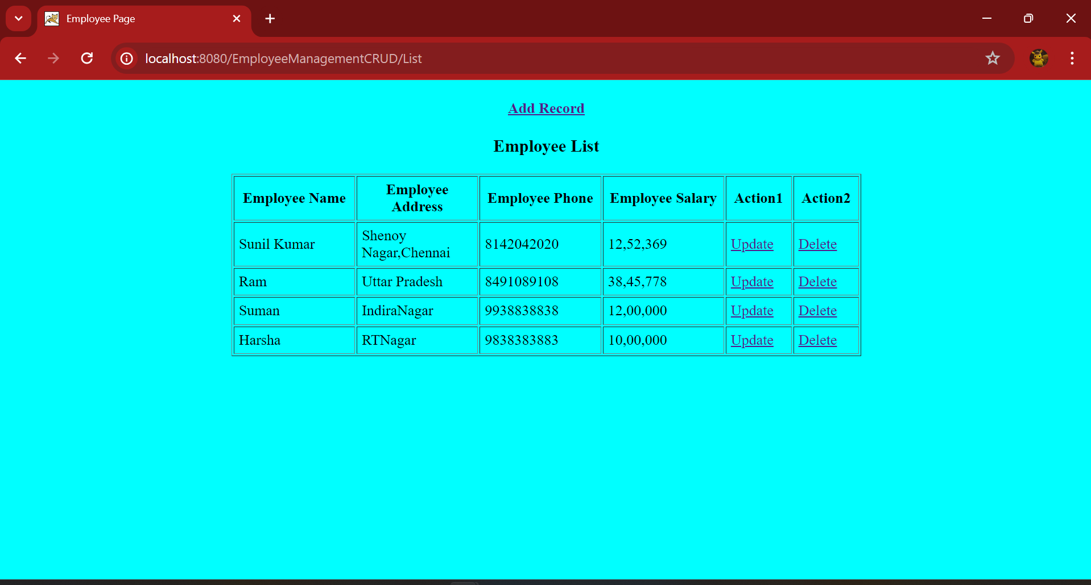

Clicking on “Update” link -- It will Take us to below page

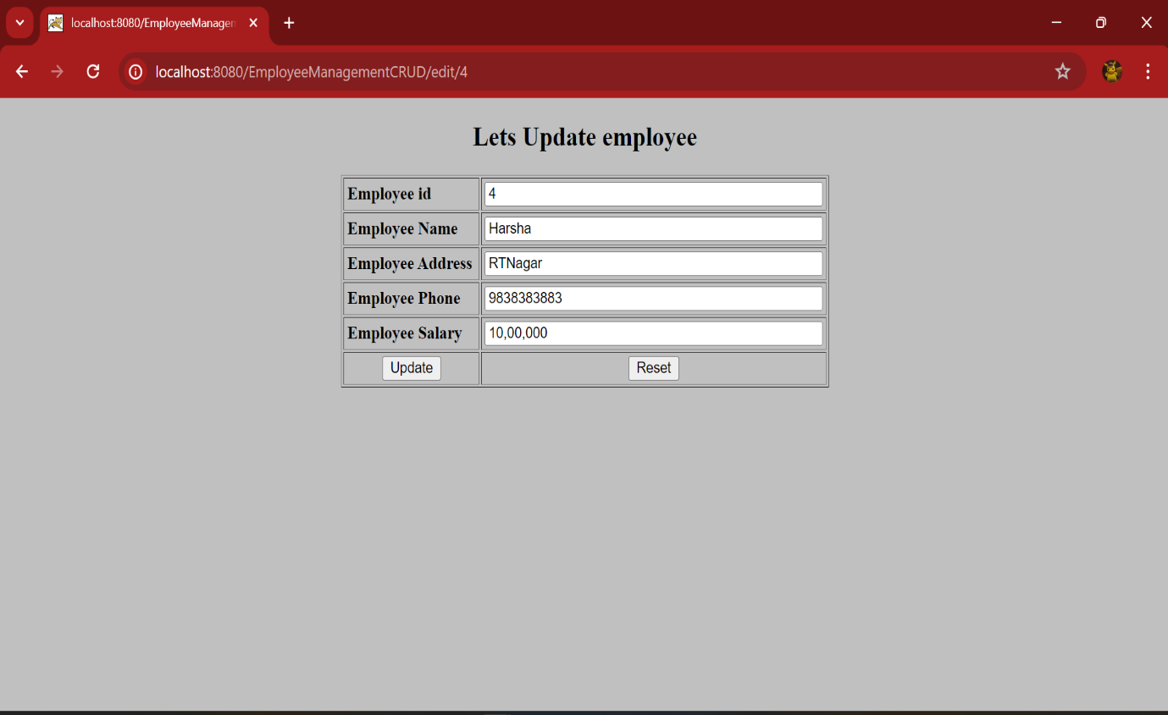

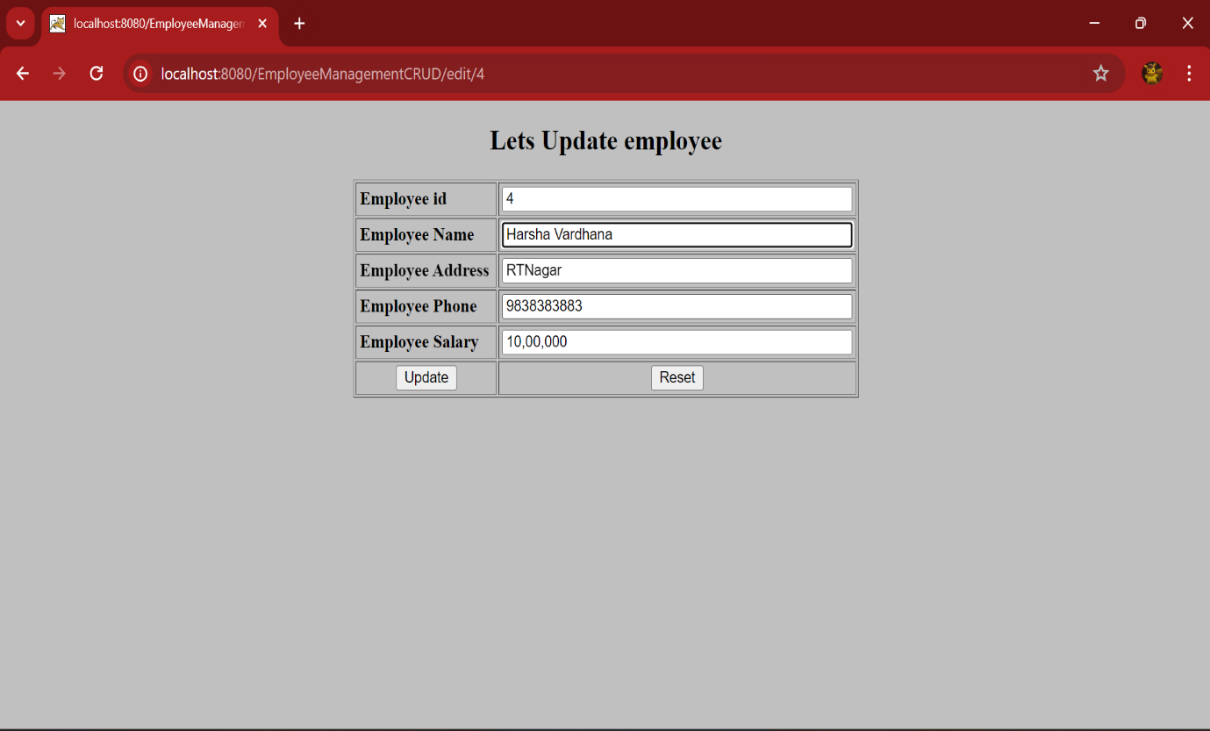

On Updation & Saving the above data , it should show up the updated list as shown below:

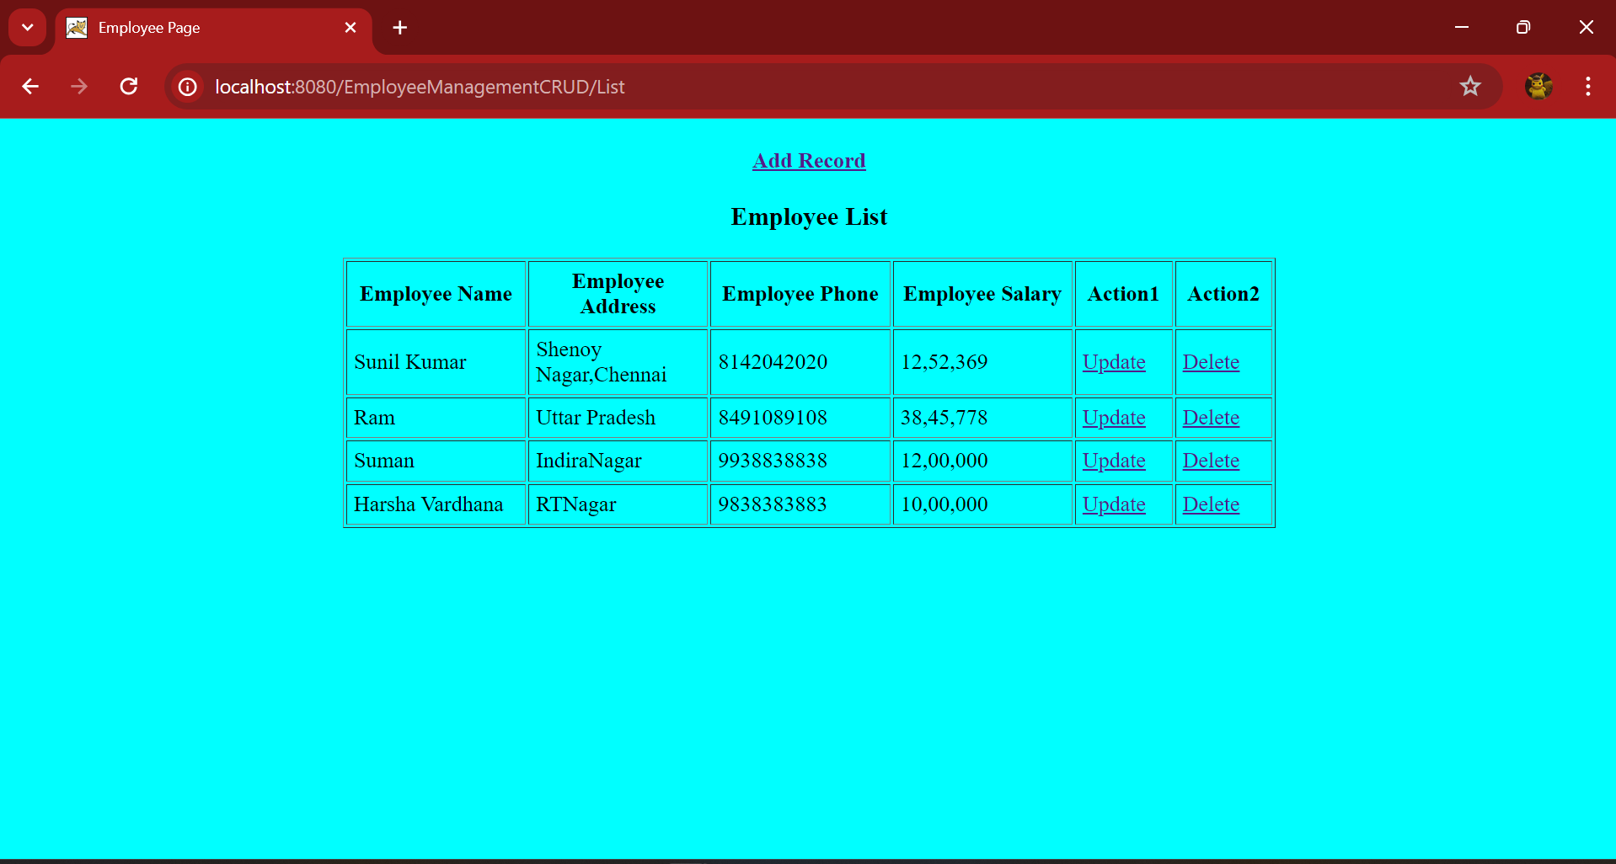

Clicking on Delete link It deleted the record and listed the updated List as show below

